Design and Evaluation of Tactile Number Reading Methods on Smartphones

【Summary】:

In this article, we propose two novel ways to read tactile numbers on a smartphone using TPad. These two methods are implemented using different finger movements (left / right or up and down) as interactive gestures.

【Number Encoding and Combination】：

We choose four numbers as the number unit: 0, 1, 2, and 5, and other numbers combined with the number unit. For example, the number 6 can be composed of 1 and 5, and the number 9 can be composed of 2, 2 and 5. See the paper for details.

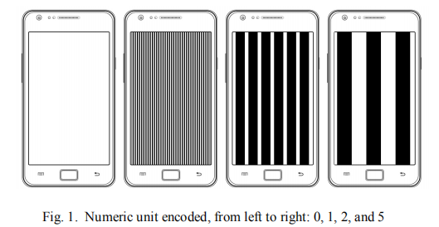 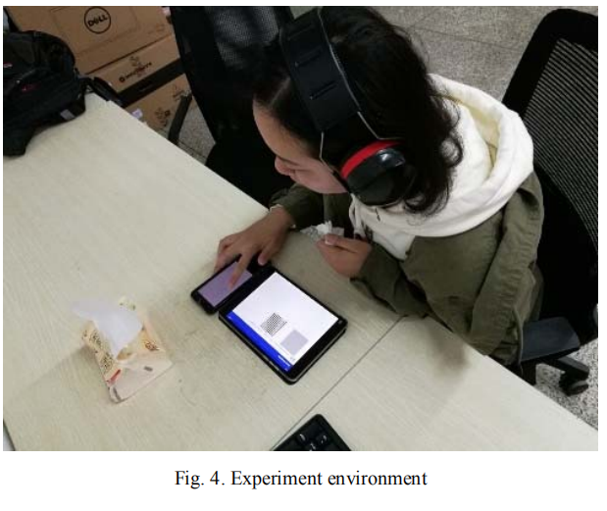

【Experiments】：

**Apparatus：**TPad phone (Android OS as client) and tablet (Android OS as server)

**Experiment record:** The main relevant indicators are interaction efficiency, recognition accuracy and user's subjective satisfaction. Interaction efficiency is used to report recognition time (milliseconds), which is the time it takes a participant to perceive tactile numbers. Recognition accuracy was introduced to measure the accuracy of each method for each tactile number. User subjective satisfaction is used to reflect user preferences for each method through a Likert questionnaire.

**Procedure：**

Before the experiment, we demonstrated the experimental equipment, interaction methods and goals to the participants. Then, we asked them to try to understand the sense of touch by letting them experience the friction and vibration of touch. Thereafter, we showed participants all the tactile digital patterns and asked them to undergo a training process to become familiar with all tactile perception.

In this experiment, a Latin Square was used to achieve balance. We divided the topics into three groups of four participants. Each group conducted experiments in a different order. Each course is conducted in two phases: the training phase, and then the experimental phase. During the training phase, participants can choose the number on the server screen themselves. When the number is sent to the client, the participant can see the tactile texture on the client screen and try to perceive and remember the tactile number pattern. In the experimental phase, the numbers (0-9) are sent by the server to the client in a random order. Each number appears randomly five times. The tactile digital mode has no visual feedback on the screen. Instruct the participant to move a finger on the screen to perceive the tactile digital pattern. When the server has sent the number information to the customer and the participant touches the customer's screen, the server starts timing until the participant's finger touches the screen. The timing process continues until your finger leaves the screen and selects the number identified on the server. This process aims to record recognition time and interaction efficiency. At the same time, the server records the selected numbers to improve identification accuracy.

1. **Left-right swipe (LRSM) gesture interaction method:**

**Operating procedures:**

We map each digital unit as a textured fullscreen portrait orientation interval. The reading mode is as follows: When the user's finger touches the screen and starts moving left or right, the system provides the tactile texture of the digital unit on the screen, and then immediately provides the tactile texture of another digital unit. When the user is perceiving the tactile texture When moving your finger in the opposite direction. This process continues until the user perceives the haptic texture as zero. For example, combine 6 with digital units 1 and 5. First, if the user moves his finger to the left on the screen, they can perceive the tactile sensation of the number 1. Then, the user can move his finger in the correct direction and can feel the feedback signal of the tactile texture of the number 5, and finally move the finger again Move to the left until you feel the texture number is zero, which indicates that the reading is complete.

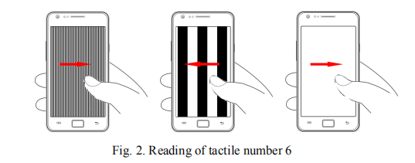

1. **LRSM gesture:**

**Operating procedures:**

The LRSM gesture divides each digital unit into the entire texture and the vertical direction. Using this method, the stripes of the haptic texture are horizontal. In addition, the entire texture is evenly divided into four regions in the vertical direction. All digital unit stripes are placed in different areas with one texture. The user's finger touches the top of the screen and moves from the top of the screen to the bottom of the screen. Similarly, the user adds all the number units together to get the final number.

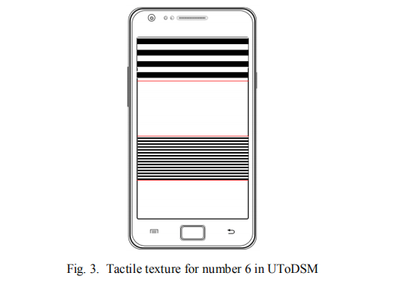

1. **(For comparison) In haptic mode, we use the duration (pulse length) and time interval of the haptic stimulus to encode the number unit.**

**Results:**

Interactive Efficiency

Recognition Accuracy

User Subjective Satisfaction with 7-point Likert Scale

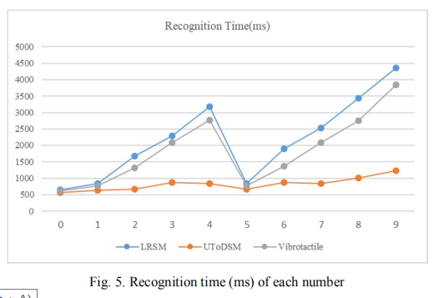 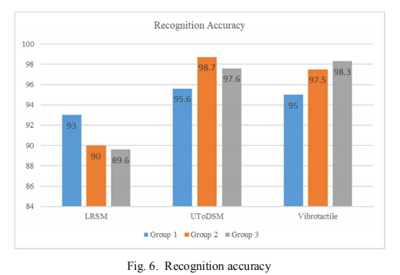 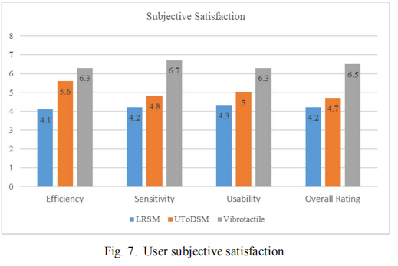

**Discuss:**

1. We find that UToDSM leads to the highest interaction efficiency and stability, followed by haptic methods and LRSM.
2. UToDSM and vibrotactile methods achieved the highest accuracy during the experiment, while LRSM produced the lowest accuracy.
3. Through the user subjective satisfaction questionnaire survey, we found that most participants preferred the tactile and tactile methods over LRSM and UToDSM. One reason is that smartphone vibration is more familiar and intuitive. The other is the low tactile quality of feedback from the friction-based method. However, the participants felt that the dynamic friction touch brought new ideas.

【Future work mentioned in the paper】：

In future work, we hope to improve haptic devices based on dynamic friction to enhance haptic feedback. We will also encode more numbers and find a more suitable encoding method to increase the tactile sensation of the numbers on the TPad. In addition, we extended the number encoding to more characters.

【Important Reference】:

[1] Grussenmeyer, W. and E. Folmer, Accessible Touchscreen Technology for People with Visual Impairments: A Survey. ACM Transactions on Accessible Computing (TACCESS), 2017. 9(2): p. 6.

[2] Guerreiro, T., Accessibility layers: levelling the field for blind people in mobile social contexts. ACM SIGACCESS Accessibility and Computing, 2015(113): p. 22-28.

[3] Al-Qudah, Z., et al., Utilizing Mobile Devices' Tactile Feedback for Presenting Braille Characters: An Optimized Approach for Fast Reading and Long Battery Life. Interacting with Computers, 2013.26(1): p. 63-74.

[9] Birnholtz, J., et al. Feeling Aware: Investigating the Use of a Mobile Variable-Friction Tactile Display for Awareness Information. in Proceedings of the 17th International Conference on Human-Computer Interaction with Mobile Devices and Services. 2015. ACM.

[10] Rantala, J., et al., Methods for presenting braille characters on a mobile device with a touchscreen and tactile feedback. IEEE Transactions on Haptics, 2009. 2(1): p. 28-39.

[14] Brewster, S. and L.M. Brown. Tactons: structured tactile messages for non-visual information display. in Proceedings of the fifth conference on Australasian user interface-Volume 28. 2004. Australian Computer Society, Inc.

[15] Chu, S., et al. Experimental Evaluation of Tactile Patterns over Frictional Surface on Mobile Phones. in Proceedings of the Fifth International Symposium of Chinese CHI. 2017. ACM.